**Adjustment for one personnel**:NKECHI FOR INSTANT

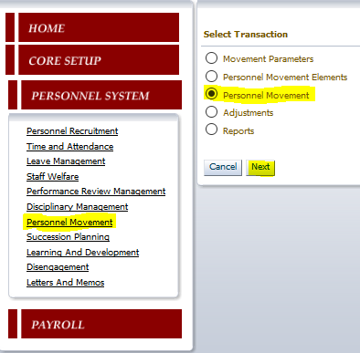

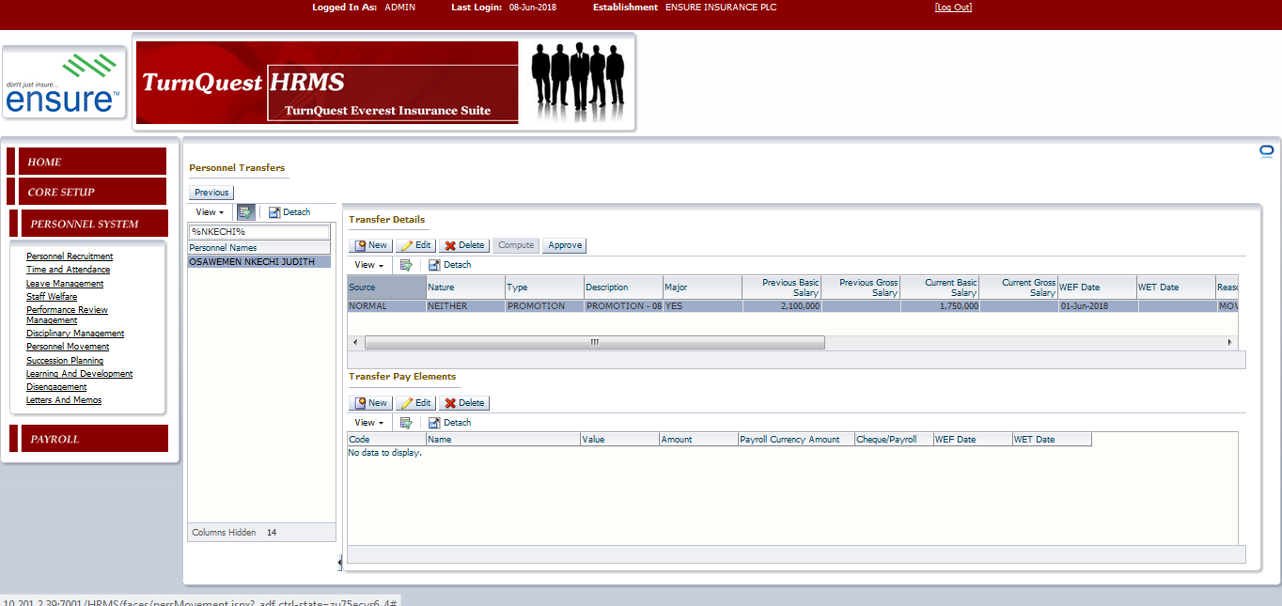

Click new and fill in details….

* Type: Promotion
* Post/postlevel: post level
* Post/postlevel details: MGR_NEW
* Category: Pick the respective category for Nkechi
* WEF Date: 01-june-2018
* Reason: Give a brief reason for adjusting her post level.
* Click on the drop down salary scale button to pick the (MGR_NEW) where Nkechi will be moved too.Save
* Approve the transfer.

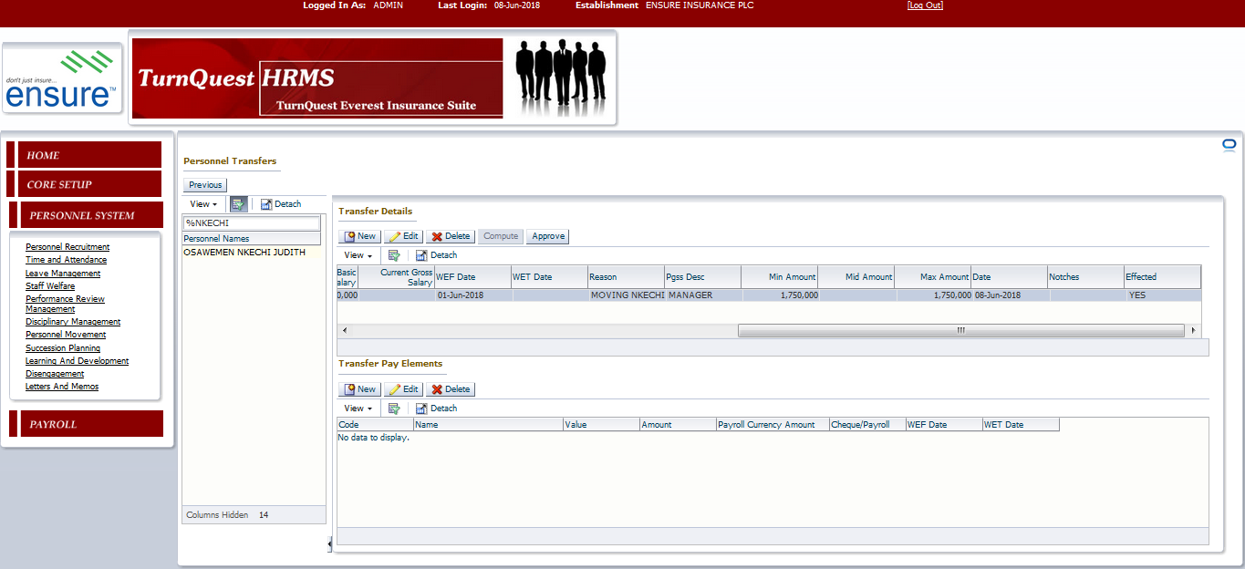

* Go to Personnel recruitment
* Filter for Personnel(Nkechi)

Note: Nkechi is no longer tag to Manager 1

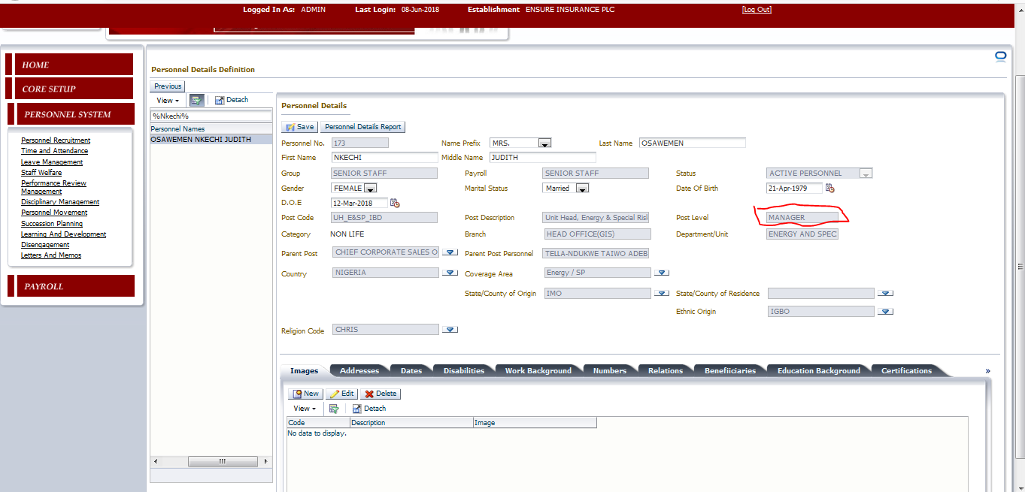

* Undo the Manager increment and reprocess again

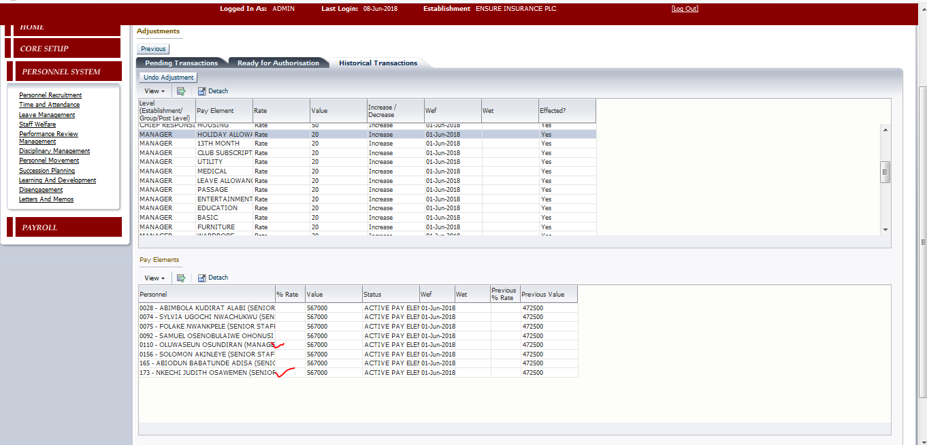

* Process June payroll and generate pay slip for MGR_NEW